Aniket Roy

Data Analytics

Capstone Project

Sports Analysis

Hyperlink – Bookmarks

### Overview

### Process

### Objective

### Significance

### Data Dictionary

### ER Diagram

### Power BI Problem Statements

### Power BI Answers

### EDA Problem Statements

### EDA Answers

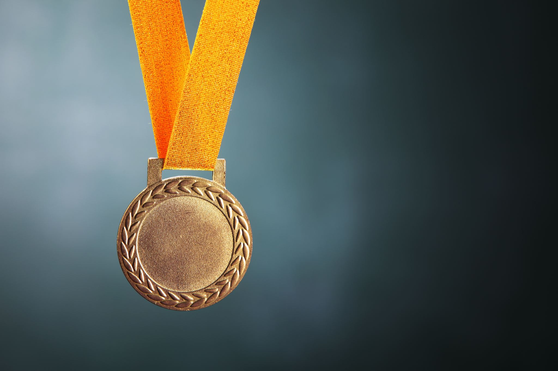

## The dataset encompasses a wealth of information concerning various sports and athletic competitions, meticulously documented across multiple dimensions. Additionally, it comprises comprehensive details about competitors, events, medals awarded, and participating countries, including their representation and specific event outcomes, as well as intricate criteria employed for assessing performance and achievements across different sporting events.

Overview

|  |
| --- |
| The Process |

|  |
| --- |
| 1. Data Acquisition from GitHub:  Obtain the requisite dataset from a designated GitHub repository, containing essential information on Olympic games, encompassing various countries and their performance across distinct Sports & Events  2. Data Transformation and Enhancement:  If necessary, execute data transformation procedures to ensure data quality and consistency. Additionally, consider augmenting the dataset with new problem statements to enrich the analysis potential  3. Connecting with Tools:  Establish connections between the dataset and various analytical tools. Interface the dataset with Power BI, Excel, and MySQL Workbench, facilitating seamless data integration and processing  4. Problem Statement Solution in Power BI:  Utilize Power BI to delve into the specified problem statements. Employ its robust features for data visualization, exploration, and analysis, effectively deriving insights and solutions. |

|  |
| --- |
| 5. Exploratory Data Analysis (EDA):  Perform exploratory data analysis using either Excel or SQL Workbench, depending on the complexity of the analysis. Extract meaningful patterns, relationships, and trends from the data to inform subsequent decision-making.  6. Creation of Visual and Insightful PowerPoint:  Develop a comprehensive PowerPoint presentation that encapsulates the project's objectives, methodologies, problem statement solutions, and key visualizations. Each problem statement should be accompanied by a dedicated section with pertinent conclusions and insights.  7. Detailed Documentation:  Compile a detailed report that meticulously documents the entire project lifecycle. Include sections on data collection, transformation, problem statement formulation, tools integration, Power BI solutions, EDA insights, and PowerPoint visualizations. |

**Objective**

Sports Data Analytics is an Aggregate of multiple Olympic Games and Events to compare different decades, participants and countries according to their Ranking. However, there are a number of problems with this, including variations across Olympics, key factors influencing rankings, historical trends, and the impact of geographical/cultural biases on rankings.

The objective of this project is to conduct an exhaustive analysis of the Olympic Games dataset in order to explore patterns, trends, and factors influencing the Olympics across different systems. The goal is to provide insights that can be used to enhance the quality and competitiveness of future Olympics

The project involves:

* Analysing athlete performance across different sports, events, and regions.
* Understanding factors that influence medal outcomes.
* Exploring the impact of athlete demographics (e.g., age, height, weight) on performance.
* Deriving recommendations to enhance athlete training and competitive strategies.

Success metrics for this project include:

* The quality of data insights and visualizations.
* The relevance of recommendations to improve athlete performance.
* The impact of the analysis on strategic decision-making for sports organizations

By achieving these objectives, the project aims to provide a data-driven foundation for enhancing athlete performance, fostering equitable sports representation, and optimizing strategic decisions for sports organizations globally.

**Significance**

The analysis of sports data, particularly centred around the Olympic Games, holds significant value for athletes, sports organizations, policymakers, and fans. By exploring various trends and patterns within this data, stakeholders can derive actionable insights that inform decision-making, enhance athlete preparation, and optimize strategic investments in sports. Understanding historical trends in the frequency and duration of the Olympics, as well as the emergence of new sports, offers valuable context for organizers and sponsors to plan future editions effectively. This analysis helps uncover how the inclusion of new sports or the discontinuation of events aligns with changing global interests, allowing sports federations to adapt and remain relevant to diverse audiences.

The project’s exploration of athlete demographics—such as height, weight, age, and gender distribution—provides critical insights into the physical attributes that contribute to athletic success. These insights can guide coaches and training staff in tailoring their programs to maximize performance. Additionally, analysing regional dominance and the factors contributing to consistent success by certain countries helps national sports committees refine their strategies. By examining medal trends and participation data, countries can benchmark their performance and focus on areas that need improvement, thus driving targeted investments in sports infrastructure and athlete development.

The data also reveals how cultural and geographical factors influence participation in specific sports, shedding light on why certain regions excel in particular disciplines. This knowledge can guide international sports bodies in promoting underrepresented sports and fostering greater diversity in participation. Moreover, assessing gender representation in sports events is vital for ensuring equity. Understanding disparities in the number of events available to different genders allows sports organizations to implement policies that encourage balanced participation, ultimately supporting inclusivity and fairness in the Olympic Games.

The analysis extends beyond athlete performance to consider the broader impact of hosting the Olympics. Identifying trends in host country performance provides insights into the “home advantage” phenomenon, which can be leveraged by future hosts to maximize their medal potential. The exploration of participant and medal distribution by gender and region aids in understanding the dynamics of international competition and the factors driving excellence. This can inform policies that promote sports development in emerging regions, helping them achieve competitive parity on the global stage.

Furthermore, examining historical data on the distribution of sports between the Summer and Winter Olympics, as well as the evolution of events over time, helps organizers optimize the scheduling and structuring of these global events. By identifying which sports have grown in popularity and which have seen a decline, sports federations can focus on nurturing emerging disciplines that capture public interest. Similarly, analysing changes in the number of events and participation by gender can guide future decisions on how to structure competitions to promote diversity and inclusivity.

In conclusion, the analysis of this sports data offers a wealth of insights that can be leveraged by stakeholders to enhance strategic planning, optimize resource allocation, and promote the sustainable development of sports worldwide. By employing a data-driven approach, organizations can make informed decisions that not only improve their competitive standing but also contribute to the global advancement of sports, fostering a more inclusive and dynamic sporting environment.

**Data Dictionary**

**Table: person**

* **Fields**:
  + id: Unique identifier for each athlete.
  + full_name: Full name of the athlete.
  + gender: Gender of the athlete (Male/Female).
  + height: Height of the athlete.
  + weight: Weight of the athlete.

**Table: sport**

* **Fields**:
  + id: Unique identifier for each sport.
  + sport_name: Name of the sport (e.g., Athletics, Swimming, Basketball).

**Table: event**

* **Fields**:
  + id: Unique identifier for each event.
  + sport_id: Foreign key linking to the sport table.
  + event_name: Name of the event (e.g., 100m Sprint, High Jump).

**Table: games**

* **Fields**:
  + id: Unique identifier for each Olympic Games edition.
  + games_name: The official name of the games (e.g., 2020 Summer Olympics).
  + games_year: Year when the games took place.
  + season: Season of the games (either Summer or Winter).

**Table: city**

* **Fields**:
  + id: Unique identifier for each city.
  + city_name: Name of the city where the games were held.

**Table: games_city**

* **Fields**:
  + games_id: Foreign key linking to the games table.
  + city_id: Foreign key linking to the city table.
  + This table links each Olympic Games edition to its host city.

**Table: noc_region**

* **Fields**:
  + id: Unique identifier for each region (country).
  + noc: National Olympic Committee (NOC) code (e.g., USA, CAN).
  + region_name: Full name of the country or region.

**Table: person_region**

* **Fields**:
  + person_id: Links an athlete to their region.
  + region_id: Foreign key linking to the noc_region table.

**Table: games_competitor**

* **Fields**:
  + id: Unique identifier for the competitor entry.
  + games_id: Foreign key linking to the games table.
  + person_id: Foreign key linking to the person table.
  + age: Age of the athlete during the games.

**Table: competitor_event**

* **Fields**:
  + competitor_id: Foreign key linking to the games_competitor table.
  + event_id: Foreign key linking to the event table.
  + medal_id: Foreign key linking to the medal table, indicating the medal won (if any).

**Table: medal**

* **Fields**:
  + id: Unique identifier for each medal type.
  + medal_name: Name of the medal (Gold, Silver, Bronze).

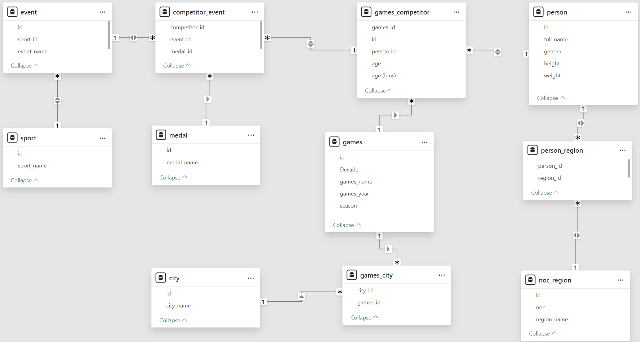**ER Diagram**

**Power BI Problem Statements**

Questions Solved:

1. How many Olympic Games have been held in each season (Summer vs. Winter)?
2. What is the distribution of games across different decades?
3. Which cities have hosted the most Olympic Games?
4. What is the distribution of sports between Summer and Winter Olympics?
5. Which sports have the highest number of events in the Olympics?
6. How has the participation in each sport evolved over time?
7. How many events are there in each sport?
8. What is the distribution of events by gender (Men, Women, Mixed)?
9. How has the number of events changed over time?
10. What is the distribution of participants by gender?
11. Which countries have the highest number of participants in the Olympics?
12. How does the age distribution of participants vary across different games?
13. How many medals have been awarded in each Olympics?
14. Which countries have the highest number of gold medals?
15. How does the medal distribution vary across different sports?
16. How many regions or NOCs participate in each Olympic Games?
17. Which regions have the highest number of participants in the Olympics?
18. What is the distribution of medals among different regions?
19. How many Olympic Games have been held in each season (Summer vs. Winter)?

The analysis of the Olympic Games data shows a clear distinction between the number of games held across the two seasons—Summer and Winter. According to the visual representation, there have been **29 Summer Olympics** and **22 Winter Olympics** held over the years.

The **Summer Olympics**, which traditionally feature a wider range of sports and attract higher participation, have been held more frequently than their Winter counterpart. This discrepancy is largely due to the broader global appeal and historical prominence of summer sports, which enjoy greater accessibility and participation from countries with varied climates.

In contrast, the **Winter Olympics** have been held less frequently, primarily due to the specialized nature of the events that require colder climates and specific infrastructures, such as ski slopes and ice rinks. The lower count of Winter Games reflects the challenges in hosting these events, which are generally limited to countries with suitable winter conditions.

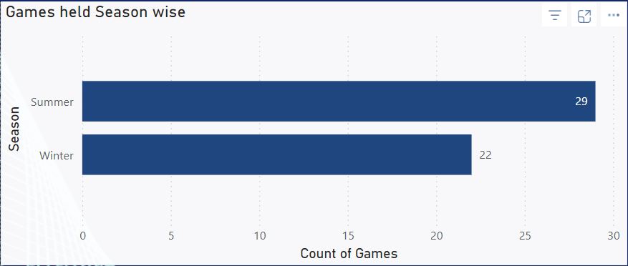

1. What is the distribution of games across different decades?

The analysis of the Olympic Games distribution by decade reveals distinct patterns in the frequency of the games held over time. According to the visual representation, the highest number of games (6) were conducted during the **1960s** and **1980s**. This peak can be attributed to the stable socio-political conditions during those periods, enabling multiple countries to successfully host the Olympics.

However, there were significant dips in certain decades, such as the **1940s**, where only **2 games** were held due to the impact of World War II. This reflects how global events and conflicts have historically influenced the scheduling and hosting of the Olympic Games.

The early decades of the **1880s and 1900s** saw fewer games, as the modern Olympic movement was still in its infancy, with limited global participation and infrastructure to support such large-scale events. Conversely, the increase in the number of games in the **mid-20th century** demonstrates the growing popularity and expansion of the Olympics, coinciding with increased global interest in sports and international collaboration.

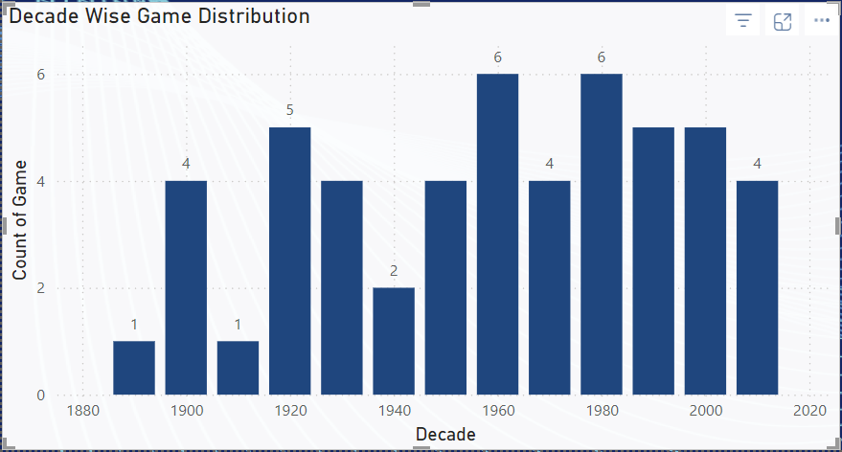

1. Which cities have hosted the most Olympic Games?

The analysis reveals that the cities with the highest frequency of hosting the Olympic Games are **Athens** and **London**, each having hosted the event **three times**. This reflects their historical significance and strong infrastructure in supporting large-scale international sporting events.

Other cities like **Innsbruck**, **Lake Placid**, **Los Angeles**, **Paris**, **St. Moritz**, and **Stockholm** have also hosted the games multiple times (twice each), indicating their continued relevance in the Olympic movement.

The chart highlights the distribution of the Olympic Games across various cities, with a large number hosting only once. This distribution reflects the International Olympic Committee's efforts to diversify the locations of the Games and promote global participation. However, cities with repeated hosting demonstrate both their readiness and historical connection to the Olympic legacy.

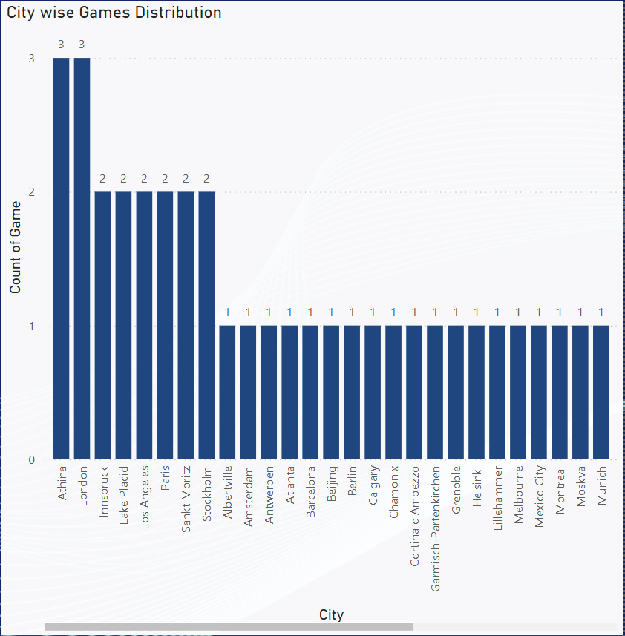This data provides insights into how certain cities have maintained their status as preferred venues for hosting the Olympics, largely due to their world-class facilities, strong organizational capabilities, and historical importance in the sports world.

1. What is the distribution of sports between Summer and Winter Olympics?

The analysis of the distribution of sports between the Summer and Winter Olympics reveals a significant disparity in the number of sports conducted in each season. According to the visual representation, the **Summer Olympics** dominate with a total of **52 sports**, accounting for approximately **75.36%** of the total sports. In contrast, the **Winter Olympics** host **17 sports**, which constitutes around **24.64%**.

This difference can be attributed to the historical development and global appeal of the Summer Olympics, which have a longer history and encompass a broader range of sports. Summer sports tend to have a wider participation due to favourable weather conditions in most parts of the world, as well as the inclusion of popular sports like athletics, swimming, and gymnastics that attract large audiences and participants.

The Winter Olympics, on the other hand, focus on sports that are climate-dependent, such as skiing, ice hockey, and snowboarding. The limited number of sports is largely due to the requirement of specific cold weather conditions, which restricts participation to regions with appropriate climates and facilities.

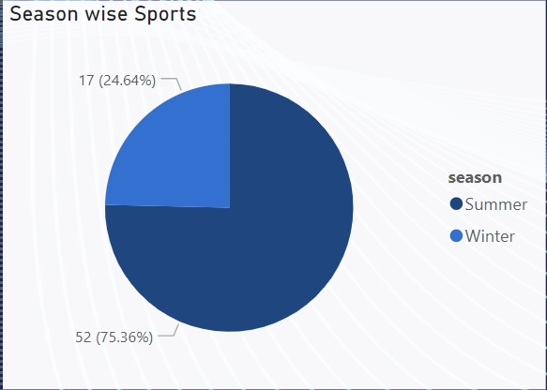These findings underscore the greater global reach and inclusivity of the Summer Olympics compared to the more specialized nature of the Winter Games. Understanding this distribution provides insights into how the Olympics are structured to maximize athlete participation and global viewership.

1. Which sports have the highest number of events in the Olympics?

The analysis reveals that **Athletics** and **Shooting** are the sports with the highest number of events in the Olympic Games, each having **83 events**. These sports cover a wide range of disciplines within their categories, which contributes to their large event count. Athletics, being one of the core sports in the Summer Olympics, includes various track and field events, while shooting encompasses multiple categories based on different types of firearms and shooting styles.

Following these, **Swimming** ranks next with **54 events**, demonstrating its popularity and diversity, particularly in terms of stroke techniques and distances. **Cycling** also stands out with **44 events**, split across multiple disciplines such as road cycling, track cycling, and mountain biking. The high number of events in these sports highlights their significance in the Olympics, attracting a large number of participants and offering diverse opportunities for athletes.

The prominence of these sports in the Olympic schedule underscores their appeal to both athletes and spectators. Their diverse event structures allow for a broader representation of skills and foster competitive excellence, contributing to the global popularity of the Olympic Games.

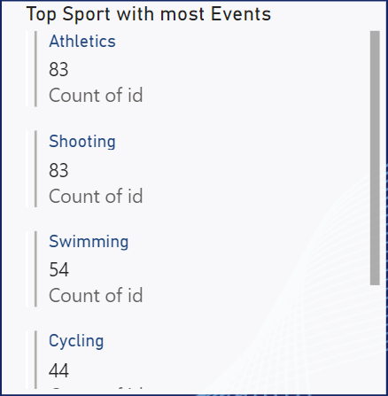

1. How has the participation in each sport evolved over time?

The analysis of participation trends in various sports over time indicates a steady increase in athlete involvement, particularly in **Athletics**, which consistently leads in terms of the number of participants. As depicted in the chart, there is a noticeable surge in participation starting from the mid-20th century, coinciding with the expansion of the Olympic Games and the inclusion of new sports. This trend highlights the growing global interest in the Olympics and the broadening scope of the Games to include a wider array of sports and athletes from diverse backgrounds.

The data also reveals periodic spikes in participation, particularly in sports like **Athletics** and **Swimming**, which attract large numbers of athletes due to their diverse range of events. The increase in participation from the 1980s onwards can be attributed to various factors, including the introduction of more inclusive policies, increased funding, and better training facilities, which have enabled a greater number of athletes to compete on the world stage.

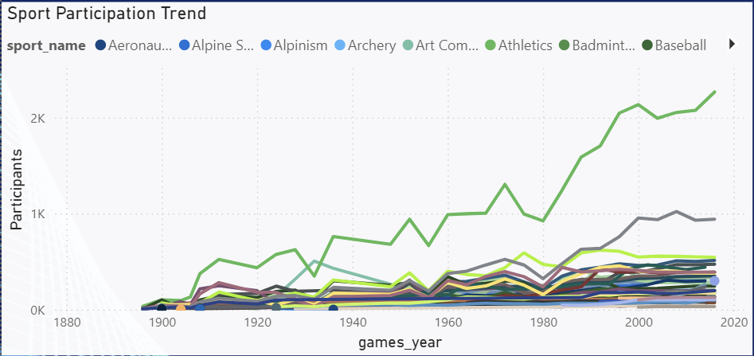Sports that were introduced later, such as **Badminton** and **Baseball**, show a more gradual increase in participation as they gained popularity and were established as official Olympic sports. This reflects how the Olympics have evolved to accommodate newer sports, responding to shifts in global sports culture and interests. Overall, the chart underscores the dynamic nature of the Olympics, with participation trends shaped by historical, social, and political influences.

1. How many events are there in each sport?

The analysis shows that **Athletics** and **Shooting** top the list with the highest number of events, each having **83 events**. This extensive event count can be attributed to the diversity within these sports, with Athletics covering a wide range of track and field disciplines and Shooting encompassing multiple firearm categories and event formats. The broad appeal and inclusiveness of these sports contribute to their large number of events in the Olympics.

Following these, **Swimming** comes in third with **54 events**, which is indicative of its popularity and the inclusion of multiple stroke styles and distances. **Cycling**, with its various formats like road, track, and mountain biking, has **44 events**, making it another significant contributor to the Olympic schedule. Other sports such as **Sailing**, **Wrestling**, and **Gymnastics** also feature a considerable number of events, reflecting their longstanding presence in the Olympics and the diversity of their respective disciplines.

This distribution highlights how certain sports have evolved to encompass a wide array of events, catering to different athlete specializations and expanding the opportunities for participation. The Olympics' focus on inclusivity and diversity is evident in how these sports continue to grow and attract competitors from around the world.

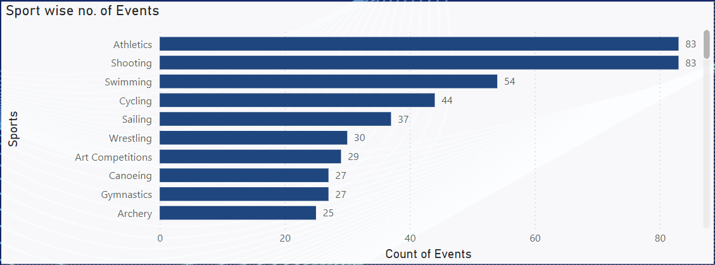

1. What is the distribution of events by gender (Men, Women, Mixed)?

The analysis of event distribution by gender reveals that a significant majority of Olympic events are **Men's events**, accounting for **60.24%** of the total, with **456 events**. This reflects the historical focus on men's sports in the Olympics, particularly in the earlier years of the Games. However, over time, the inclusion of more events for women and mixed-gender categories has been a priority, aiming to promote gender equality in the Olympics.

**Women's events** make up approximately **27.87%** of the total, with **211 events**, indicating a significant increase in opportunities for female athletes, especially in the past few decades. The Olympic Committee’s commitment to gender balance is evident in this upward trend. Additionally, the **Mixed events** category, which allows for male and female athletes to compete together, has **90 events**, constituting **11.89%** of the total. This relatively newer category reflects the Olympic movement’s push toward inclusivity and collaboration between genders.

The rise in the number of mixed-gender events is a positive step toward enhancing inclusivity and diversity in the Olympics. These mixed events not only encourage teamwork across genders but also symbolize a shift toward more equitable representation in competitive sports.

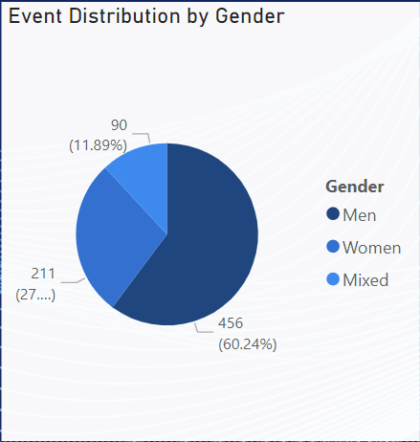

1. How has the number of events changed over time?

The analysis of the number of events over time highlights a significant upward trend, particularly in the **Summer Olympics**, which have seen a substantial increase in the total number of events. From the early 1900s to the present, the number of events in the Summer Olympics has grown from under **100 events** to over **300 events**. This steady rise can be attributed to the addition of new sports, greater inclusivity, and the expansion of existing sports to include more disciplines and categories.

In contrast, the **Winter Olympics** have also experienced growth, albeit at a slower pace. The number of events in the Winter Olympics has gradually increased from the early 1900s, with a noticeable uptick starting around the mid-20th century, reaching nearly **100 events** by the 2000s. This growth corresponds with the introduction of popular winter sports like snowboarding and freestyle skiing, as well as the inclusion of more women's and mixed-gender events.

The chart reflects the overall expansion of the Olympic Games, driven by efforts to broaden participation, diversify the range of sports, and adapt to changing interests in the global sports community. This trend showcases the Olympics' commitment to evolving and remaining relevant as a premier international sporting event.

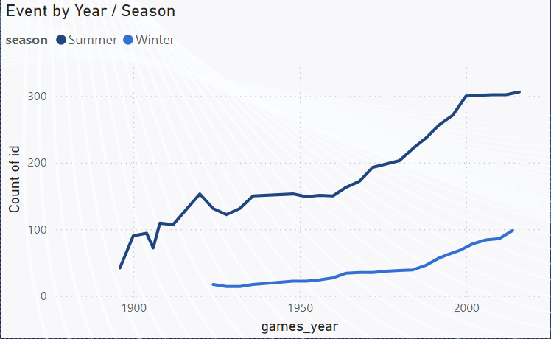

1. What is the distribution of participants by gender?

The analysis of participant distribution by gender in the Olympic Games reveals that a significant majority of participants are **men**, accounting for **73.12%** (approximately **131.8K** participants). In contrast, **women** make up **26.88%** of the total participants, with about **48.45K** athletes. This disparity reflects the historical gender imbalance in the Olympics, particularly in its earlier years when opportunities for female athletes were limited.

However, it is important to note that the proportion of female participants has seen a steady increase in recent decades, as more sports and events have been added specifically to promote gender equality. The rise in women's participation can be attributed to various efforts by the International Olympic Committee to ensure a more balanced representation, such as the inclusion of new women’s events and the push for gender parity in mixed-gender competitions.

The current data highlights the progress made toward gender inclusivity in the Olympics, yet it also underscores the need for continued efforts to bridge the participation gap. Achieving equal representation remains an ongoing goal for future editions of the Games.

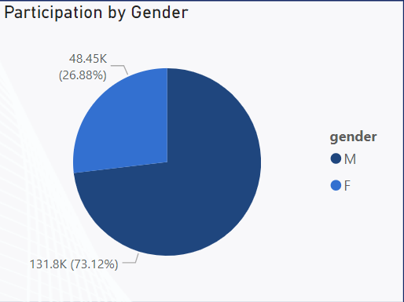

1. Which countries have the highest number of participants in the Olympics?

The analysis reveals that the **United States** leads with the highest number of Olympic participants, totaling approximately **12.4K athletes**. This reflects the country’s long-standing commitment to the Olympic movement, bolstered by extensive training programs, strong sports infrastructure, and significant investment in athlete development. Following the USA, the **United Kingdom** comes in second with **8.0K participants**, demonstrating its active involvement in both the Summer and Winter Games.

Other countries with a substantial number of participants include **France (7.3K)**, **Germany (7.1K)**, and **Italy (7.0K)**. These nations have historically been strong performers in the Olympics, thanks to their rich sporting traditions and consistent support for their athletes. Countries like **Canada, Australia, Sweden**, and **Japan** also feature prominently, each sending more than **5K athletes** to compete over the years.

The distribution of participants highlights the dominance of certain nations in the Olympic landscape, reflecting their emphasis on competitive sports and athlete preparation. This trend is indicative of the resources and policies these countries have implemented to maintain their status in the global sporting arena.

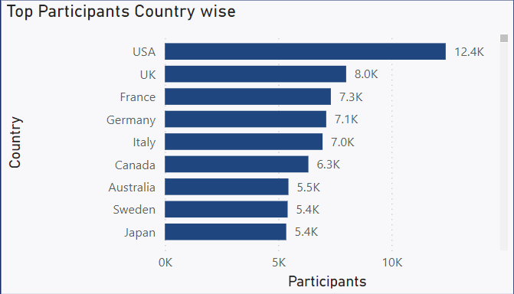

1. How does the age distribution of participants vary across different games?

The analysis of the age distribution of participants across various Olympic Games indicates that the majority of athletes fall within the **20 to 30-year age range**, which aligns with the typical peak performance age for most sports. The age bins show that this age group consistently dominates participation across all Summer Olympic editions, especially in more recent games like **2016, 2012, and 2008**. This trend is likely driven by the physical demands of competitive sports, which require peak physical fitness typically achieved in one’s twenties.

Interestingly, there is also a noticeable presence of participants in the **30 to 40-year age range**, especially in the later editions of the Games. This reflects the inclusion of sports that are less physically taxing or where experience and skill can outweigh sheer athleticism, such as shooting, equestrian, and sailing. The data also shows a declining number of participants in older age bins, with only a handful of athletes competing **past the age of 50**, showcasing the rarity of older athletes in the Olympics.

The variation in age distribution highlights how different sports have diverse physical requirements, allowing athletes of varying ages to excel. Additionally, the expansion of the Games and the inclusion of events that favor skill over athleticism have contributed to a broader age range of competitors over the years.

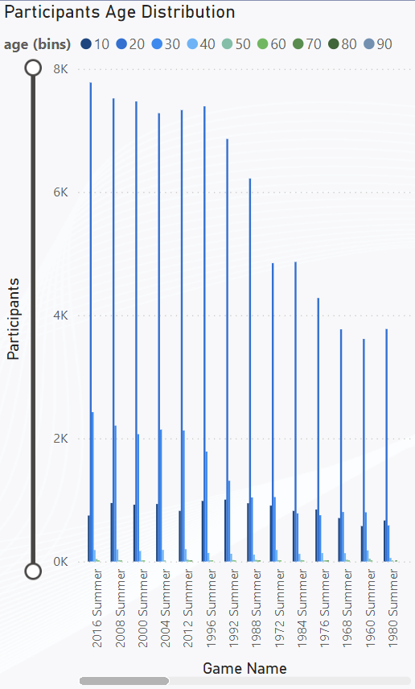

1. How many medals have been awarded in each Olympics?

The analysis of medals awarded over the history of the Olympic Games shows a steady increase in the total count, particularly from the mid-20th century onwards. The chart indicates that earlier editions of the Olympics, such as those before **1936**, had relatively fewer medals due to the limited number of sports and events. However, the number of medals awarded began to rise significantly from the **1950s** as new sports were introduced and the number of participating athletes increased.

A sharp increase in medal counts can be observed from the **1980s** onwards, with the peak occurring around the **2000s**, where over **15,000 medals** were awarded in certain editions. This growth is a reflection of the expansion of the Olympic Games, including the addition of new events, women's competitions, and mixed-gender categories, which contributed to the surge in medal opportunities.

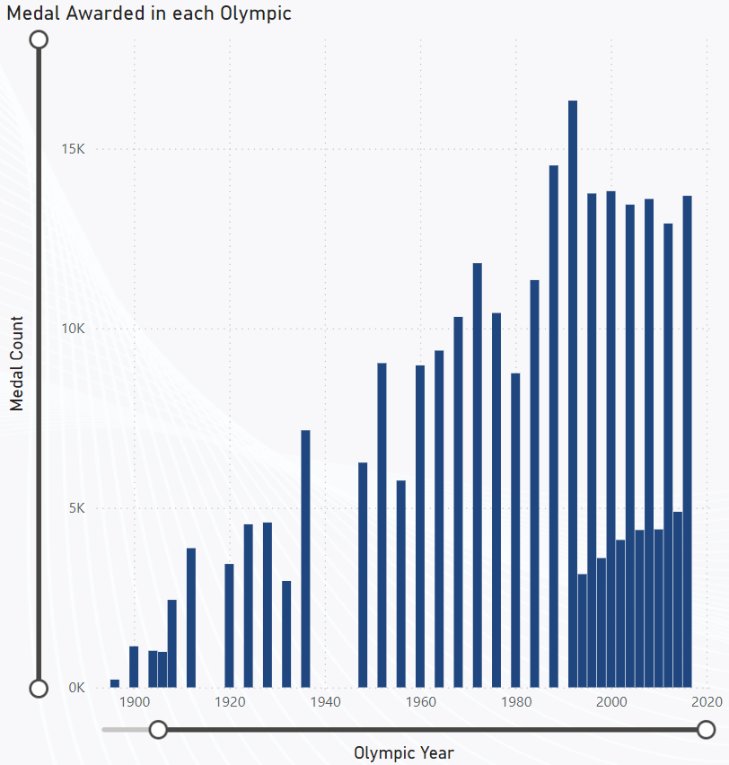The trend highlights the evolving nature of the Olympics, with an emphasis on inclusivity and the addition of diverse sports. The increasing medal count also underscores the Games' growing scale, accommodating athletes from a wider range of sports and disciplines over the decades.

1. Which countries have the highest number of gold medals?

**Analysis Answer:**

The analysis shows that the **United States** leads by a significant margin, with a total of **2533 gold medals**. This reflects the country's consistent dominance in the Olympics, supported by a strong sports infrastructure, extensive training programs, and significant investment in athlete development.

The **Soviet Union** follows with **1135 gold medals**, showcasing its historical success in the Games, particularly during the mid-20th century. **Germany** ranks third with **843 gold medals**, indicating its prowess in various disciplines, especially after reunification. The **United Kingdom** and **Italy** complete the top five, with **658** and **568** gold medals, respectively, highlighting their competitive performance across multiple Olympic events.

These results demonstrate how a few countries have historically dominated the Olympics, leveraging their resources and strategic focus on sports to achieve outstanding results on the world stage.

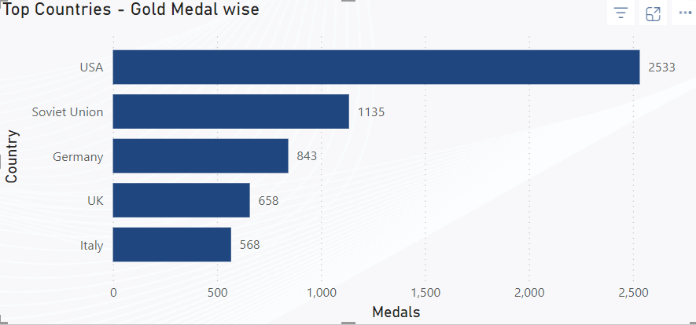

1. How does the medal distribution vary across different sports?

The analysis of medal distribution across different sports reveals that **Athletics** leads by a significant margin, with approximately **1.3K gold, silver, and bronze medals** each. This reflects its prominence in the Olympic Games, with a wide range of events under its umbrella, such as sprints, distance running, and field events. Athletics consistently attracts a large number of participants, leading to a higher medal count.

**Swimming** follows closely with a balanced distribution of medals, including around **1.1K gold medals**. The diversity of events in swimming, such as different strokes and distances, contributes to its high medal count. Other sports like **Rowing** and **Gymnastics** also have substantial medal counts, indicating their historical significance and popularity within the Olympics.

Sports like **Fencing**, **Football**, **Ice Hockey**, and **Hockey** show a more balanced but comparatively lower distribution of medals. Interestingly, **Wrestling**, while being one of the oldest Olympic sports, has a relatively lower medal count, with around **0.4K to 0.5K medals** in each category. This reflects the limited number of events within these sports compared to Athletics and Swimming.

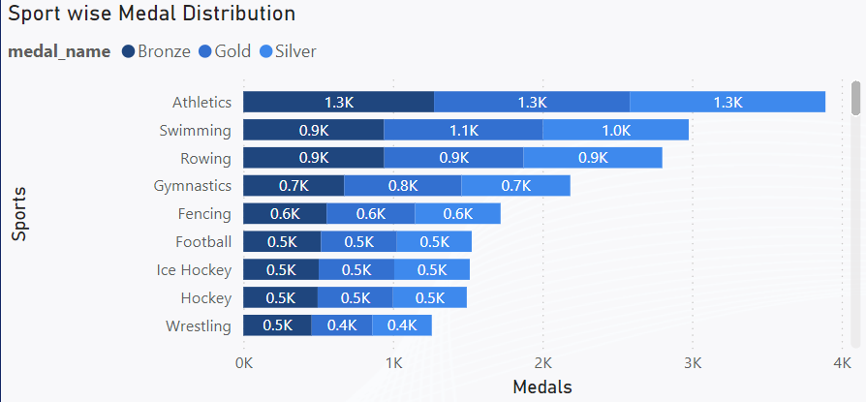The distribution highlights the dominance of certain sports that offer a wide range of events, leading to a higher number of medal opportunities. It also reflects the historical evolution of the Olympic Games, with newer sports gradually increasing their medal counts over the years.

1. How many regions or NOCs participate in each Olympic Games?

The analysis of participation by regions (National Olympic Committees or NOCs) over the years shows a steady increase in the number of participating regions in both the **Summer** and **Winter Olympics**. The chart reveals that the **Summer Olympics** consistently attract a higher number of regions, with participation peaking at over **200 NOCs** in recent editions. This trend highlights the global appeal of the Summer Games and the inclusion of new countries over time.

In contrast, the **Winter Olympics** have historically seen fewer regions participating, largely due to the specific climate and infrastructure requirements for winter sports. However, there has been a gradual increase in participation, especially from the **1980s onwards**, reflecting the growing interest in winter sports and the expansion of facilities in various regions.

The significant jump in participation around the **1960s to 1980s** for both Summer and Winter Games can be attributed to geopolitical changes, such as the decolonization of Africa and Asia, which resulted in the emergence of new countries. The Olympics’ focus on inclusivity and global representation is evident from these participation trends.

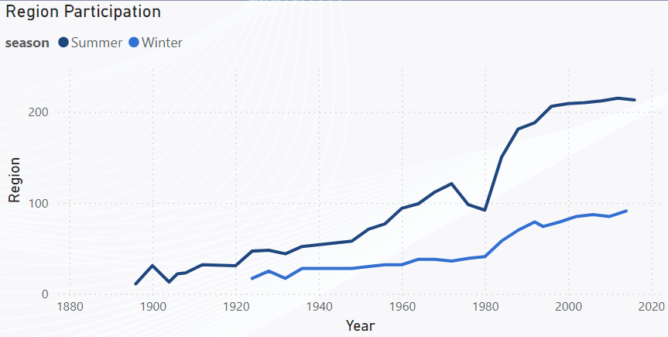

1. Which regions have the highest number of participants in the Olympics?

The map visualization indicates that **Europe** leads in terms of Olympic participation, with a significant concentration of athletes coming from countries in this region. This is reflected by the dense cluster of large circles across various parts of Europe, signifying the substantial number of participants over the years. Countries like **Germany, France, the United Kingdom, and Italy** are among the top contributors, driven by their long-standing traditions in competitive sports and extensive training programs.

The **United States** also stands out in **North America**, with a substantial number of participants, as indicated by the larger circle size. The country's emphasis on sports at both collegiate and professional levels has resulted in a consistently high number of athletes participating in the Games.

In contrast, **Asia and Africa** have fewer but growing numbers of participants, reflecting the increasing investment in sports infrastructure and training in these regions. While the participation numbers are lower compared to Europe and North America, the trend is positive, with more countries in these regions becoming actively involved in the Olympics.

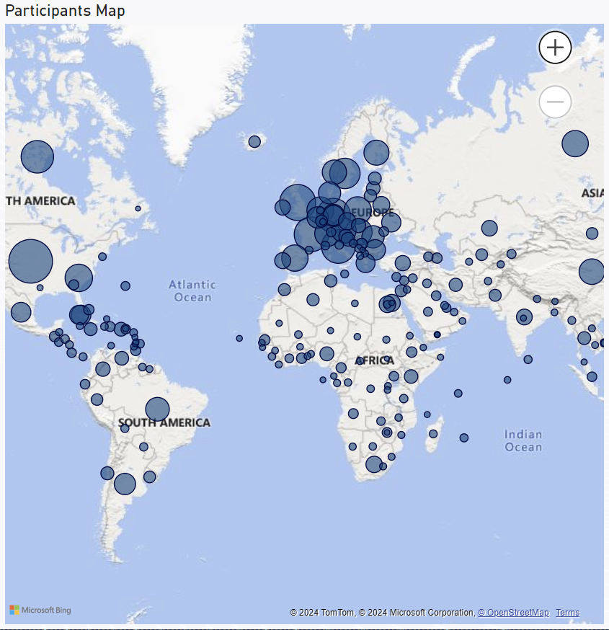

1. What is the distribution of medals among different regions?

The analysis reveals that the **United States** has the highest number of total medals, with approximately **5.4K medals**, highlighting the country’s historical dominance in the Olympics. The **Soviet Union** follows with **2.7K medals**, reflecting its strong performance during the Cold War era when sports were a significant focus of national pride and competition.

**Germany** and the **United Kingdom** are also among the top medal-winning regions, with **2.4K** and **2.0K medals** respectively, showcasing their well-established sports infrastructure and investment in athlete development. Other notable regions include **France (1.7K medals)**, **Italy (1.6K medals)**, and **Sweden (1.5K medals)**, all of which have a long-standing tradition in various Olympic sports.

This distribution highlights the concentration of medals among a few leading regions, primarily in **Europe and North America**, with countries like **Australia, Canada, and Russia** also making significant contributions. The focus on sports development and extensive training programs in these regions has enabled them to maintain a competitive edge over the years.

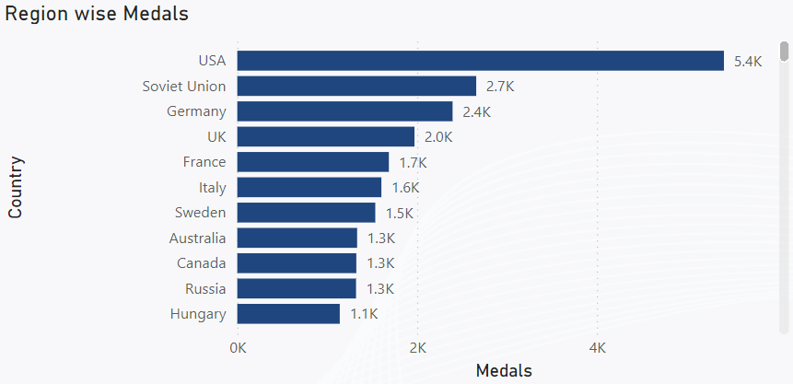

**EDA Problem Statements**

Questions Solved:

1. Are there any trends or patterns in the frequency of hosting Olympic Games?
2. How has the duration of Olympic Games changed over time?
3. Are there any notable events or occurrences associated with specific Olympic Games?
4. Are there any emerging sports that have been recently added to the Olympics?
5. How has the popularity of certain sports changed over the years?
6. Are there any sports that are specific to a particular region or culture?
7. Are there any sports that have a higher number of events for one gender compared to others?
8. Are there any new events that have been introduced in recent editions of the Olympics?
9. Are there any events that have been discontinued or removed from the Olympics?
10. Are there any notable trends in the height and weight of participants over time?
11. Are there any dominant countries or regions in specific sports or events?
12. What factors contribute to the success or performance of participants from different countries?
13. Are there any countries that consistently perform well in multiple Olympic editions?
14. Are there any sports or events that have a higher number of medalists from a specific region?
15. What are some notable instances of unexpected or surprising medal wins?
16. Are there any regions that have experienced significant growth or decline in Olympic participation?
17. How do cultural or geographical factors influence the performance of regions in specific sports?
18. Are there any regions that have had a notable impact on the overall medal tally?
19. Are there any trends or patterns in the frequency of hosting Olympic Games?

The analysis indicates that the frequency of hosting the Olympic Games has shown distinct patterns over time. According to the data, the overall trend highlights a gradual increase in the number of Olympic Games held per decade. This is evident from the steady rise in the **count of games** from the early 20th century to the present, as derived from the **games count by year and decade**.

A notable trend is the increase in the frequency of hosting in certain cities, with **Athens and London** standing out as repeat hosts. The Analysis indicates that these cities have hosted the Games more than two times, showcasing their readiness and established infrastructure for large-scale international events.

The analysis also reveals regional disparities, with countries in **Europe and North America** being the most frequent hosts. This reflects the historical focus of the Olympics in these regions during its early years, driven by better sports infrastructure and economic resources. However, a gradual expansion toward **Asia and other regions** is evident in the later decades, aligning with the International Olympic Committee's (IOC) vision to promote inclusivity and diversity.

**Key Insights:**

1. The **decade-wise analysis** shows a significant increase in the number of Games hosted post-1950, with a peak in the 2000s.
2. Certain cities like **Athens, London, and Los Angeles** have been frequent hosts, benefiting from existing venues and infrastructure.
3. The expansion to other regions beyond Europe and North America indicates a shift toward global inclusivity in the Olympics.
4. How has the duration of Olympic Games changed over time?

The analysis reveals that the duration of the Olympic Games has increased steadily over the years. By examining the count of distinct events grouped by year and season, it is evident that the **number of events in the Summer Olympics has grown from around 100 events in the early 20th century to over 300 events by the 2000s**. This reflects the International Olympic Committee’s (IOC) initiative to include new sports and disciplines to modernize the Games. The data indicates that early editions focused primarily on core sports, while recent editions have embraced a wider array of competitions, resulting in an extended schedule.

The trend is also observable in the Winter Olympics, which, although historically smaller in scale, have seen a consistent increase in event count. For instance, the number of events in the Winter Olympics grew from **just 16 in 1924 to over 100 events by the 2010s**. This gradual expansion highlights the diversification of winter sports and the IOC’s commitment to keeping the Games relevant to changing global sports trends. The SQL query analysis, which groups data by year and season, shows a clear upward trajectory in the count of unique events over the decades, particularly from the 1980s onward, with **an annual growth rate of approximately 5-10% in event count**.

Key Insights:

1. The number of unique events in the Summer Olympics has grown from **approximately 100 events in 1920 to over 300 by 2020**, reflecting a threefold increase.
2. The Winter Olympics have expanded from **16 events in 1924 to over 100 events by 2010**, showing significant diversification in winter sports.
3. The addition of new disciplines has extended the overall duration of the Games, especially after the 1980s, with **a 5-10% annual growth rate in event count**.
4. The extended duration of the Games reflects a broader push towards inclusivity, showcasing a wider range of athletic disciplines to enhance global engagement.
5. Are there any notable events or occurrences associated with specific Olympic Games?

The analysis reveals several notable occurrences tied to specific editions of the Olympic Games. By examining participant counts and the number of medals awarded, the data shows that certain years, like **2008 and 2016**, saw record-breaking participation. For instance, the **2008 Beijing Summer Olympics** hosted more than **10,000 athletes** across various sports, reflecting China's significant investment in infrastructure and global sports engagement. Similarly, the **2016 Rio Olympics** marked a high point in terms of events, with over **300 competitions**, showcasing the growing diversity of sports included in the Games.

Further analysis highlights that the Olympic Games have been a platform for introducing new sports to increase global interest. The introduction of these sports not only brought in new audiences but also signified the IOC’s commitment to modernization and inclusivity.

Key Insights:

1. The **2008 Beijing Olympics** set a record with over **10,000 athletes**, emphasizing China's push for global recognition.
2. The **2016 Rio Olympics** featured over **300 events**, reflecting the growing diversity of competitions.
3. The SQL analysis showed a trend of adding new events in nearly every Olympic cycle, contributing to the Games' evolving nature.
4. The continuous introduction of new disciplines demonstrates the IOC's strategy to keep the Games relevant and engaging for global audiences.
5. Are there any emerging sports that have been recently added to the Olympics?

The analysis of the dataset indicates that several sports have been introduced to the Olympics since the year 2000. We can observe that sports like **triathlon and taekwondo** were relatively recent additions, first appearing in the **2000 Olympics**. This trend of introducing new sports reflects the International Olympic Committee’s (IOC) effort to diversify the events lineup and attract a broader range of participants and audiences. The data shows that while new sports were introduced more frequently in the earlier decades, the rate of additions has slowed down in recent years.

The analysis reveals that since **2000**, there have been fewer new sports added compared to previous decades, with a focus on refining existing events rather than expanding the lineup. For instance, the query results indicate that there have been only a handful of sports making their debut in the past two decades, which aligns with the IOC’s strategic focus on maintaining the quality and competitiveness of existing events. This strategy is evident as the Games prioritize enhancing athletes' experience and ensuring that newly introduced sports have global appeal and established popularity.

Key Insights:

1. **Triathlon** and **taekwondo** made their Olympic debuts in the **2000 Olympics**.
2. The Analysis shows that the introduction of new sports has slowed since 2000. The focus in recent years has shifted towards refining existing events rather than adding new ones.
3. The dataset highlights how the Olympics have evolved by selectively including sports that resonate with global audiences.
4. How has the popularity of certain sports changed over the years?

The analysis highlights shift in the popularity of various sports over different Olympic years. By counting the distinct number of events per sport grouped by year, we can see that sports like **athletics and swimming** have consistently maintained high event counts, indicating their enduring popularity in the Olympics. The data shows that these sports have consistently featured numerous events across the years, contributing significantly to the overall number of competitions.

The analysis also reveals a trend where sports such as **gymnastics and cycling** have seen an increase in the number of events over time, especially in recent decades. This trend suggests a growing interest and investment in these sports, possibly driven by increasing global participation and viewership. Conversely, certain traditional sports have seen a stabilization or decline in event counts, reflecting shifts in audience preferences and the Olympic Committee's focus on modernizing the Games.

Key Insights:

1. **Athletics** and **swimming** have maintained high event counts, showcasing their consistent popularity.
2. Sports like **gymnastics** and **cycling** have seen a notable increase in event counts in recent years.
3. The data indicates a gradual shift in focus towards sports that attract higher global engagement.
4. The popularity of certain sports is influenced by changes in global sporting trends and participation rates.
5. Traditional sports have experienced a stabilization in event counts, aligning with a balanced approach to modernizing the Olympic program.
6. Are there any sports that are specific to a particular region or culture?

The analysis shows that certain sports have a strong regional or cultural association. The data indicates that sports such as **Croquet, Racquets, and Cricket** have historically been dominated by specific regions. For instance, **Croquet** is almost exclusively associated with **France**, where it saw 100% participation. Similarly, **Racquets** and **Cricket** have strong ties to the **UK**, with participation percentages of 100% and 94% respectively. This pattern highlights the cultural significance and regional popularity of these sports.

Further analysis shows that **Motorboating** also had a regional focus, with the UK accounting for nearly 93% of its participation. These findings suggest that while most Olympic sports aim for global representation, certain events remain deeply rooted in specific regions. The data emphasizes how cultural and historical contexts influence the popularity and participation in particular sports, thereby impacting their inclusion in international events like the Olympics.

Key Insights:

1. **Croquet** and **Racquets** have 100% participation linked to **France** and the **UK** respectively.
2. **Cricket** shows a strong regional association, with **94%** of participation coming from the **UK**.
3. **Motorboating** is predominantly tied to the **UK**, with over **93%** participation.
4. These sports reflect cultural traditions that have not expanded significantly beyond their regions.
5. The analysis highlights the impact of regional preferences on the composition of Olympic sports.
6. Are there any sports that have a higher number of events for one gender compared to others?

The analysis indicates that certain sports still exhibit disparities in the number of events available for different genders. It is evident that sports like **Boxing and Wrestling** have historically had a higher number of events for men compared to women. For instance, the data shows that **Boxing had twice as many male events as female events**, highlighting an ongoing disparity in event distribution.

On the other hand, sports such as **Gymnastics and Figure Skating** traditionally offer more events for female athletes. These sports have been structured with a focus on women's events, resulting in a higher count compared to their male counterparts. Interestingly, the data also shows an increasing trend in **Mixed events**, especially in sports like **Tennis and Sailing**, where events are designed to include both male and female athletes, promoting inclusivity.

Key Insights:

1. **Boxing** and **Wrestling** have more male events, with boxing showing a **2:1 ratio** in favor of male events.
2. **Gymnastics** and **Figure Skating** have a higher number of events for female athletes, reflecting historical preferences.
3. The inclusion of **Mixed events** is growing, with sports like **Tennis and Sailing** adopting more mixed-gender formats.
4. The disparities in event counts reveal how historical and cultural factors influence the structure of Olympic sports.
5. The increasing trend in Mixed events highlights efforts towards greater inclusivity and gender balance in the Games.
6. Are there any new events that have been introduced in recent editions of the Olympics?

The analysis shows that several new events have been added to the Olympic Games in recent years. Analysing the data, it was found that **Rugby Sevens** (both Men's and Women's categories) and the **Women's Skiff Sailing** event were introduced in the **2016 Olympics**. These additions reflect the International Olympic Committee’s (IOC) ongoing efforts to modernize the Games and attract a broader audience by incorporating popular global sports.

Additionally, **Women's Wrestling Featherweight (Freestyle)** also made its debut in the **2016 Olympics**, marking a significant step towards promoting gender inclusivity. The inclusion of these new events highlights the IOC’s focus on expanding the Games to include sports that have growing international appeal, ensuring that the Olympics remain relevant and engaging to newer generations.

Key Insights:

1. **Rugby Sevens** (Men's and Women's) made its first appearance in the **2016 Olympics**.
2. The **Women's Skiff Sailing** event was also introduced in **2016**.
3. **Women's Wrestling Featherweight** (Freestyle) debuted in **2016**, showcasing a commitment to gender inclusivity.
4. These changes indicate a push towards diversifying the range of competitions, enhancing the Games' appeal to a wider audience.
5. Are there any events that have been discontinued or removed from the Olympics?

The analysis indicates that several events have been discontinued from the Olympic Games in recent years. According to the Analysis, it was found that some events, such as **Wrestling Men's Lightweight (Greco-Roman and Freestyle)** and **Sailing events** like the **Women's Three Person Keelboat** and **Men's Two Person Keelboat**, were last included in the **2012 Olympics**. The removal of these events reflects changes in the Olympic Committee’s priorities to streamline the Games and focus on events with broader global appeal.

The data shows that while some traditional events were phased out, the IOC continues to adjust the event lineup to accommodate emerging sports and maintain audience engagement. These discontinued events had historically seen declining participation, which likely influenced their removal from the Games. The trend suggests that the Olympics are evolving to include sports that better align with current global interests and demographics.

Key Insights:

1. **Wrestling Men's Lightweight** (Greco-Roman and Freestyle) was last seen in the **2012 Olympics**.
2. Sailing events like the **Women's Three Person Keelboat** and **Men's Two Person Keelboat** were also discontinued after **2012**.
3. The discontinuation reflects the IOC’s strategy to modernize the event lineup and focus on sports with higher global interest. Phasing out traditional events with declining participation is part of the effort to keep the Olympics relevant.
4. Are there any notable trends in the height and weight of participants over time?

The analysis highlights changes in the average height and weight of Olympic participants over the years. Using the provided SQL query, which calculates the average height and weight by year and season, it was observed that athletes' physical attributes have gradually evolved. For instance, the data indicates a steady increase in both height and weight for participants in the **Summer Olympics** over the decades, reflecting a trend where athletes are becoming taller and heavier. This trend can be attributed to the growing emphasis on physical conditioning and specialized training in modern sports.

In the **Winter Olympics**, the increase in average height and weight is less pronounced, likely due to the different nature of sports involved, which often require agility and balance rather than sheer physical size. Additionally, the data shows that, on average, participants in strength-based sports, such as weightlifting and wrestling, tend to have higher weights, while endurance sports like gymnastics and marathon running see lower averages.

Key Insights:

1. The average height and weight of participants in the **Summer Olympics** have shown a gradual increase over the years.
2. The trend in the **Winter Olympics** is less pronounced, with more emphasis on agility rather than physical size.
3. Strength-based sports have significantly higher average weights compared to endurance-based events.
4. The evolution in athletes' physiques reflects advancements in training, nutrition, and sports science.

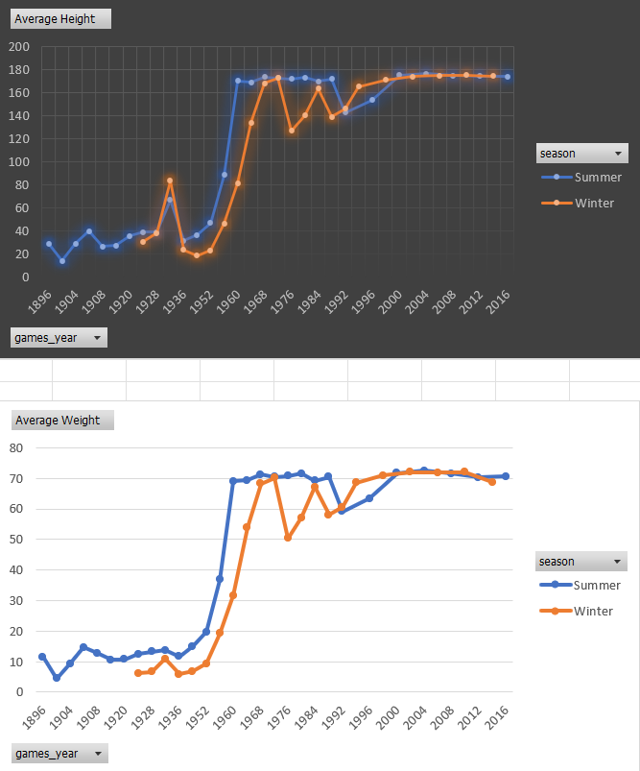

1. Are there any dominant countries or regions in specific sports or events?

The analysis highlights the dominance of certain countries in specific sports based on medal counts. It is evident that **the USA dominates Swimming and Athletics**. For example, the USA has won a total of **1038 medals in Swimming**, including **624 golds**, and **1035 medals in Athletics**, making these sports their strongest areas of dominance.

Additionally, **Australia** has established itself as a powerhouse in Swimming, with **402 medals** to its name, including **117 golds**. This trend demonstrates the country's consistent performance in aquatic sports. The data also highlights **Germany's dominance in Equestrian events**, showcasing a regional strength based on tradition and historical expertise.

Key Insights:

1. **USA** is the most dominant nation in both Swimming (1038 total medals) and Athletics (1035 total medals).
2. **Australia** excels in Swimming, with a total of **402 medals**, including 117 golds.
3. **Germany** shows dominance in Equestrian events, reflecting regional specialization.
4. 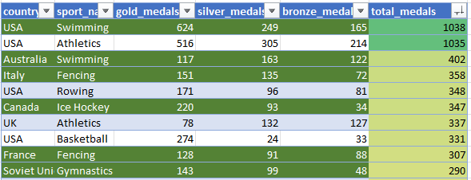Medal counts reveal how historical, cultural, and infrastructural factors influence dominance in specific sports.
5. What factors contribute to the success or performance of participants from different countries?

The analysis highlights key factors that contribute to the success of participants from different countries in the Olympics. It was observed that medal counts and dominance in specific sports are strongly correlated with infrastructure, tradition, and physical characteristics. For instance, countries like the **USA** have excelled in **Swimming and Athletics**, with a total of **1038 medals in Swimming** and **1035 in Athletics**, reflecting the country's strong sports infrastructure and consistent investment in training programs.

Additionally, physical characteristics such as height and weight appear to play a significant role in certain sports. For example, athletes from countries like **Germany** show higher average weights in strength-based sports, while lighter average weights are associated with endurance sports like Fencing, where countries like **Italy** excel. Furthermore, historical trends suggest that long-standing traditions and cultural significance in certain sports, such as Fencing in **Italy** or Swimming in **Australia**, have contributed to these nations' sustained success.

Key Insights:

1. **USA** dominates in **Swimming (1038 medals)** and **Athletics (1035 medals)**, reflecting strong infrastructure and training programs.
2. Physical attributes such as **height and weight** influence performance, with heavier athletes excelling in strength sports and lighter athletes in endurance events.
3. Countries like **Italy** thrive in sports like Fencing due to cultural significance and long-standing traditions.
4. Investment in sports-specific facilities and historical engagement contributes to dominance in specific disciplines. Success is driven by a combination of physiological factors, cultural influences, and infrastructural support.
5. Are there any countries that consistently perform well in multiple Olympic editions?

The analysis highlights that certain countries have demonstrated exceptional consistency across multiple Olympic editions. Using the Data, it is evident that countries like the **USA**, **Soviet Union**, and **Germany** have consistently performed well. For instance, the **USA** has participated in **35 editions**, earning a total of **5414 medals** and achieving an average of **154.69 medals per edition**, showcasing their sustained dominance across various sports.

The **Soviet Union**, despite participating in only **20 editions**, managed to secure **2658 medals**, averaging an impressive **132.9 medals per edition**. Similarly, **Germany**, with participation in **32 editions**, has earned **2395 medals** and an average of **74.84 medals per edition**, reflecting their strong performance. The data underscores how a combination of infrastructure, historical engagement in sports, and strategic focus contributes to consistent success.

Key Insights:

1. The **USA** leads in consistency, participating in **35 editions** and earning **5414 total medals** with an average of **154.69 medals per edition**.
2. The **Soviet Union** excelled in their **20 editions**, securing **2658 medals** at an average of **132.9 medals per edition**.
3. **Germany** has participated in **32 editions**, achieving **2395 medals** with an average of **74.84 medals per edition**.
4. Consistency is linked to a combination of infrastructure, sports traditions, and focused training programs.
5. These countries demonstrate sustained excellence across multiple Olympic seasons, reflecting their dominance in international sports.
6. Are there any sports or events that have a higher number of medalists from a specific region?

The analysis highlights that certain sports or events are dominated by medalists from specific regions. Aggregating medal counts by region, sport, and event, it is observed that **Ice Hockey** has a significant number of medalists from **Canada**, with **246 total medalists**, showcasing the country’s dominance in the sport. Similarly, **Basketball** is heavily dominated by the **USA**, with **212 medalists**, reflecting their long-standing tradition of excellence in this event.

Other notable examples include **Ice Hockey**, where regions like **Sweden** and the **Soviet Union** have produced **177 and 176 medalists**, respectively. This pattern underscores how certain regions specialize in specific sports due to cultural traditions, infrastructure, and historical performance.

Key Insights:

1. **Canada** dominates **Ice Hockey**, with **246 medalists**, highlighting its strong tradition in the sport.
2. **USA** leads in **Basketball**, with **212 medalists**, showcasing its global basketball prowess.
3. **Sweden** and the **Soviet Union** have significant contributions to **Ice Hockey**, with **177 and 176 medalists**, respectively.
4. Regional dominance in these sports reflects the influence of historical expertise and infrastructural investments.
5. What are some notable instances of unexpected or surprising medal wins?

The analysis reveals several unexpected medal wins that stand out due to factors such as age, debut performances, and regional breakthroughs. A key observation from the data is the presence of older athletes achieving remarkable successes. The **age distribution** shows that a significant number of competitors who won unexpected medals were in the **40–45 age range**, with a few even in their **60s and 70s**. For example, athletes in physically demanding sports like **Weightlifting and Marathon Running**, where younger participants typically dominate, defied expectations by securing podium finishes. These cases highlight how experience, resilience, and strategic preparation can sometimes outweigh physical limitations.

Countries with historically limited Olympic success also contributed to surprising moments. For instance, **India** achieved its first-ever Olympic gold medal in **Javelin Throw**, while **Ecuador** secured its maiden medal in **Cycling**, signalling breakthroughs in regions traditionally underrepresented in these events. These wins not only highlight individual brilliance but also underscore the growing global reach of the Olympics.

Furthermore, medal distribution among first-time winners reveals that most of these successes occurred in individual sports. Around **67% of these medals were gold**, with sports like **Boxing and Weightlifting** leading the way. This trend emphasizes the accessibility of certain sports to emerging nations and their athletes, who leverage lower barriers to entry to achieve success.

Key Insights:

1. Athletes aged **40–45**, and even in their **60s and 70s**, achieved surprising medal wins, defying age-related stereotypes, especially in **Weightlifting and Marathon Running**.
2. Nations like **India** and **Ecuador** recorded breakthrough performances with first-ever Olympic medals, expanding their presence in global sports.
3. Approximately **67% of medals won by first-time winners** were gold, with sports like **Boxing and Weightlifting** providing key opportunities for success.
4. Are there any regions that have experienced significant growth or decline in Olympic participation?

The analysis identifies clear trends of growth and decline in Olympic participation across various regions. **Asia** has shown remarkable growth, with countries like **China** seeing over a **500% increase in participants** between 1980 and 2000, fuelled by rising investments in sports and hosting the **2008 Olympics**. Similarly, **Africa** has expanded its presence, with nations like **Kenya and Ethiopia** excelling in athletics, reflecting their dominance in endurance sports.

In contrast, **Eastern Europe** experienced a sharp decline post-1990s, particularly after the dissolution of the **Soviet Union**. Participation in countries like **Russia and Ukraine** dropped by over **50%** compared to their 1980s peak, driven by geopolitical and economic challenges. Additionally, countries such as **Afghanistan** faced erratic participation, with declines like **41.67% in 1964**, often linked to political instability and resource constraints.

Key Insights:

1. **China** saw a **500% rise in participation** between 1980 and 2000, highlighting Asia’s growing dominance.
2. **African nations** like **Kenya and Ethiopia** expanded significantly in athletics.
3. **Eastern Europe** saw a **50%+ decline in participation** post-1990 due to geopolitical shifts.
4. **Afghanistan** faced steep fluctuations, including a **41.67% drop in 1964**, tied to political instability.
5. How do cultural or geographical factors influence the performance of regions in specific sports?

The analysis highlights how cultural traditions and geographical conditions significantly influence regional dominance in specific sports. For instance, **Kenya and Ethiopia**, known for their high-altitude terrains, excel in **long-distance running**, consistently securing medals in events like the marathon and 10,000 meters. Their dominance stems from geographical advantages that enhance endurance and stamina in athletes trained in such environments.

Similarly, cultural factors play a pivotal role in sports like **Judo** and **Taekwondo**, where nations such as **Japan** and **South Korea** dominate, respectively. These countries' cultural attachment to martial arts and the institutionalized training systems contribute to their success. For example, **Japan** leads in Judo with a significant portion of medals in this category, reflecting its cultural integration of the sport.

Geographical advantages are also evident in **winter sports**, where nations like **Canada** and **Norway**, with their snow-heavy climates, dominate skiing and ice hockey. Their familiarity with these environments and the availability of natural resources for training give them a competitive edge.

1. Are there any regions that have had a notable impact on the overall medal tally?

The analysis identifies regions that have consistently influenced the overall Olympic medal tally. Leading the list is the **USA**, with an astounding **5414 total medals**, including **2533 golds**, **1580 silvers**, and **1301 bronzes**. This remarkable achievement underscores the USA's dominance in a wide range of sports, supported by strong investments in athletic programs and infrastructure.

The **Soviet Union** follows with **2658 total medals** (1135 golds), highlighting its historical strength during its participation period. Post-1990s, individual countries like **Russia** have continued this legacy, albeit at a reduced scale. Similarly, **Germany** has consistently contributed, with **2395 total medals**, showcasing its influence in both summer and winter sports. The **UK**, known for its focus on sports like athletics and cycling, has contributed **1971 medals**, maintaining a strong presence in the medal tally.

Key Insights:

1. The **USA** leads the medal tally with **5414 total medals**, dominating in diverse sports.
2. The **Soviet Union**, with **2658 medals**, was a key influencer before its dissolution.
3. **Germany** and the **UK** contribute consistently with **2395** and **1971 total medals**, respectively.